ECO 101: Introduction to Microeconomics
Sample Final Exam
Lecture 14 and 15
- Define Market Structure.
- What are the characteristics of firms in Perfect Competition?
- What is the meaning of price taker? Why are perfectly competitive firms price takers (3 reasons)?
- What is the profit-maximizing condition?
- Suppose the market equilibrium price is $10 for product X. Calculate TR and MR for a perfectly competitive firm in the following table:
Price | Quantity | MR | TR
 | 1
 | 2
 | 3
 | 4
 | 5
 | 6

- What is the meaning of Resource Allocative Efficiency? (Refer to class notes to answer this).
- What is the shutdown condition of perfectly competitive firms in the short-run? (slide no. 5 and 6).
- What are the three conditions of long-run equilibrium in perfect competition?
Lecture 16, 16b and 17
- What are the characteristics of a monopoly market structure?
- What are some legal barriers to entry monopoly industry? (check slides)
- What is the difference between government monopolies and market monopolies? (check slides)
- What is the meaning of price searcher? Why are monopolies price searchers?
- Sketch the demand and marginal revenue curves of monopolies.
Problem Solving
1a. Sketch the graph of a Perfectly Competitive firm making supernormal profits in the short-run.
1b. Label the following values in your graph: P=15, ATC1 = 12, AVC1 = 9 and Q = 500. Find TR, TC, profit/loss, TVC and TFC.
1c. Will the firm continue to operate in the short-run?
2a. Sketch the graph of a Perfectly Competitive firm making normal profits in the short-run.
2b. Label the following values in your graph: P=12, AVC1 = 8 and Q = 200. Find TR, TC, profit/loss, TVC and TFC.
2c. Will the firm continue to operate in the short-run?
3a. Sketch the graph of a Perfectly Competitive firm making “shutdown” loss in the short-run.
3b. Label the following values in your graph: P=10, ATC1 = 14, AVC1 = 11 and Q = 100. Find TR, TC, profit/loss, TVC and TFC.
3c. Will the firm continue to operate in the short-run?
4a. Sketch the graph of a Perfectly Competitive firm making a loss but continuing operation in the short-run.
4b. Label the following values in your graph: P=15, ATC1 = 17, AVC1 = 12 and Q = 100. Find TR, TC, profit/loss, TVC and TFC.
4c. Will the firm continue to operate in the short-run?
5a. Sketch the perfect competition transition from short-run to long-run if firms were making supernormal profits in the short-run.
5b. Why do all firms make normal profits in the long-run?
6a. Sketch the perfect competition transition from short-run to long-run if firms were making loss in the short-run.
6b. Why do all firms make normal profits in the long-run?
7a. Sketch the graph of a perfectly competitive firm in long-run equilibrium.
7b. What are the three conditions of long-run equilibrium?
8a. Sketch a scenario where the monopoly firm is making supernormal profits.
8b. Label the following values in the graph: P = 20, ATC1 = 15, Q=100. Calculate TR, TC and profit/loss.
9a. Sketch a scenario where the monopoly firm is making loss.
9b. Label the following values in the graph: P = 10, ATC1 = 15, Q=100. Calculate TR, TC and profit/loss.
10. What is the meaning of price discrimination? What three conditions must be fulfilled for firms to apply price discrimination?
11. Explain the three types of price discrimination. Give examples of each type (explain elaborately).
12. What are the characteristics of monopolistic competition market structure?
13. What is the meaning of product differentiation?
14a. Sketch the scenario of a monopolistically competitive firm making supernormal profits in the short-run.
14b. Sketch the scenario of a monopolistically competitive firm making loss in the short-run.
15. Sketch the long-run scenario of firms in monopolistic competition.
16a. Compare monopoly profit-maximizing scenario to perfect competition profit maximizing scenario on the same graph (use constant MC).
16b. Why are monopolies less efficient than perfectly competitive firms? What is deadweight loss?
17. Compare long-run scenario of monopolistically competitive firm to a perfectly competitive firm on the same graph.
18. What are the characteristics of oligopoly market structure?
19. What is the meaning of concentration ratio?
Multiple Choice Questions
1. Perfect competition is characterized by all of the following except
A) heavy advertising by individual sellers.
B) homogeneous products.
C) sellers are price takers.
D) a horizontal demand curve for individual sellers.

2. Which of the following is not a characteristic of a perfectly competitive market structure?
A) There are a very large number of firms that are small compared to the market.
B) All firms sell identical products.
C) There are no restrictions to entry by new firms.
D) There are restrictions on exit of firms.

3. A very large number of small sellers who sell identical products imply
A) a multitude of vastly different selling prices.
B) a downward sloping demand for each seller's product.
C) the inability of one seller to influence price.
D) chaos in the market.

4. Both individual buyers and sellers in perfect competition
A) can influence the market price by their own individual actions.
B) can influence the market price by joining with a few of their competitors.
C) have to take the market price as a given.
D) have the market price dictated to them by government.

5. Which of the following is the best example of a perfectly competitive firm?
A) a corn farmer in Illinois
B) a Taco Bell restaurant
C) the Ford Motor Company
D) the United Parcel Service (UPS)

6. If the market price is $40 in a perfectly competitive market, the marginal revenue from selling
the fifth unit is
A) $8.
B) $20.
C) $40.
D) $200

7. Marginal revenue is
A) total revenue divided by the total quantity of output.
B) the change in profit divided by the change in the quantity of output.
C) the change in total revenue divided by the change in total cost.
D) the change in total revenue divided by the change in the quantity of output.

8. The marginal revenue curve for a perfectly competitive firm
A) is downward-sloping.
B) is the same as its demand curve.
C) is perfectly inelastic.
D) is the same as its marginal cost curve.

9. A perfectly competitive firm's marginal revenue
A) is greater than price.
B) is less than price because a firm must lower its price to sell more.
C) is equal to price.
D) may be either greater or less than price, depending on the quantity sold.

10. Producing where marginal revenue equals marginal cost is equivalent to producing where
A) average total cost equals average revenue.
B) average fixed cost is minimized.
C) total revenue is equal to total cost.
D) total profit is maximized.
11. If, for the last bushel of apples produced and sold by an apple farm marginal revenue exceeds
marginal cost, then in producing that bushel the farm
A) added more to total cost than it added to total revenue.
B) added an equal amount to both total revenue and total cost.
C) added more to total revenue than it added to total cost.
D) maximized its profits or minimized its losses.

12. Letters are used to represent the terms used to answer this question: price (P), quantity of
output (Q), total cost (TC) and average total cost (ATC). Which of the following equations is
equal to a firm's profit?
A) P - ATC
B) (P × Q) - TC
C) (P × Q) - (P × ATC)
D) P – TC

13. If a firm shuts down in the short run it will
A) break even.
B) declare bankruptcy.
C) suffer a loss equal to its variable costs.
D) suffer a loss equal to its fixed costs.

14. If, for a given output level, a perfectly competitive firm's price is less than its average
variable cost, the firm
A) is earning a profit.
B) should shut down.
C) should increase output.
D) should increase price.
15. Which of the following is not an option for a perfectly competitive firm that suffers short-run
losses?
A) shutting down
B) reducing production
C) reducing the use of variable factors
D) raising price

16. In a perfectly competitive industry, in the long-run equilibrium
A) the typical firm is producing at the output where its long-run average total cost is not minimized.
B) the typical firm is earning an accounting profit greater than its implicit costs.
C) the typical firm earns zero economic profit.
D) the typical firm is maximizing its revenue.

17. Fill in the columns in the following table and use the values in the table to determine the profit-maximizing level of output
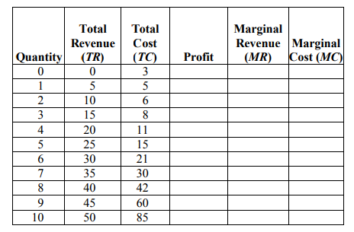
18. Which of the following statements about a monopoly is FALSE?
A) A monopoly is the only supplier of the good.
B) Monopolies have no barriers to entry or exit.
C) The good produced by a monopoly has no close substitutes.
D) None of the above; that is, all of the above answers are true statements about a monopoly
19. Which of the following is LEAST likely to be a monopoly?
A) the sole owner of an occupational license
B) a pharmaceutical company with a patent on a drug
C) a store in a large shopping mall
D) the holder of a public franchise
20. A public franchise is
A) an exclusive right granted to an inventor of a product.
B) a government issued license required to practice a profession.
C) a unique source of raw materials.
D) an exclusive right granted to a firm to supply a good or service.
21. Monopolists
A) face downward sloping demand curves.
B) are price takers.
C) have no short-run fixed costs.
D) maximize revenue, not profits.
22. Which of the following statements is true?
A) A perfectly competitive industry produces more output and charges the same price as a single-price monopoly.
B) A perfectly competitive industry produces less output but charges a lower price than a single-price monopoly.
C) A perfectly competitive industry produces less output and charges the same price as a single-price monopoly.
D) A perfectly competitive industry produces more output and charges a lower price than a single-price monopoly.
23. Which three of the following characteristics apply to oligopoly?
- The industry is often characterised by extensive non-price competition.
- Many small firms account for a high percentage of industry output.
- Each firm faces a downward sloping demand curve.
- A few large firms account for a high percentage of industry output.
- Each firm faces a horizontal demand curve.
24. One difference between perfect competition and monopolistic competition is that:
- Firms in monopolistic competition have some degree of market power.
- Monopolistic competition has barriers to entry, whereas perfect competition has none.
- There are a smaller number of firms in perfectly competitive industries.
- There are a larger number of firms in monopolistic competition.
- In perfect competition, the products are slightly differentiated between firms.
25. Price discrimination refers to charging different prices for different products in different markets.
- True
- False
Other Problems:
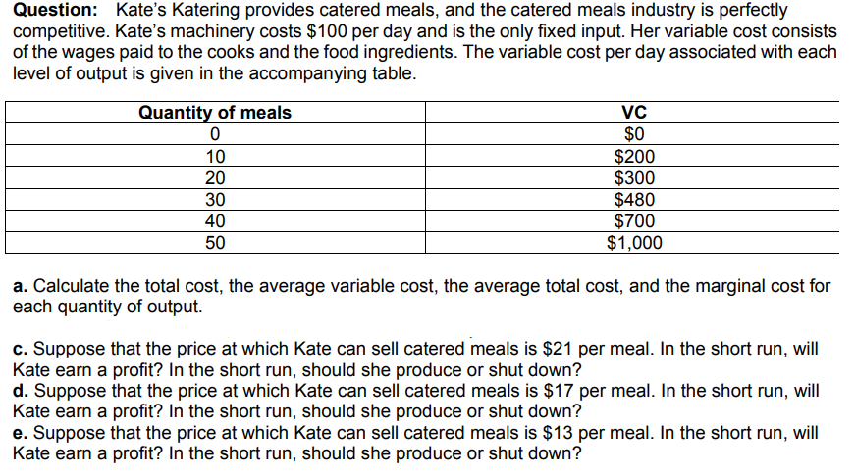
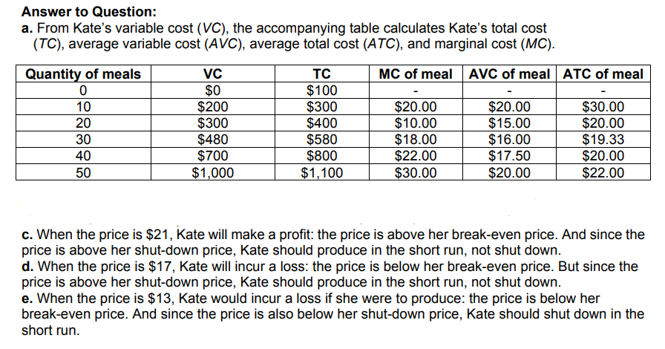
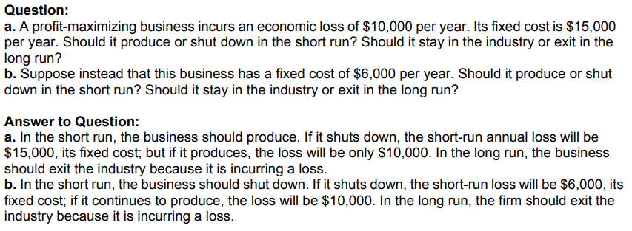

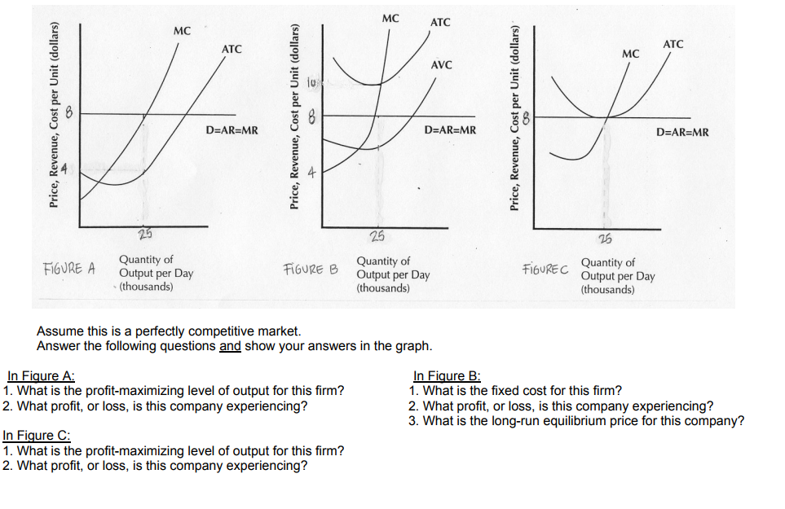
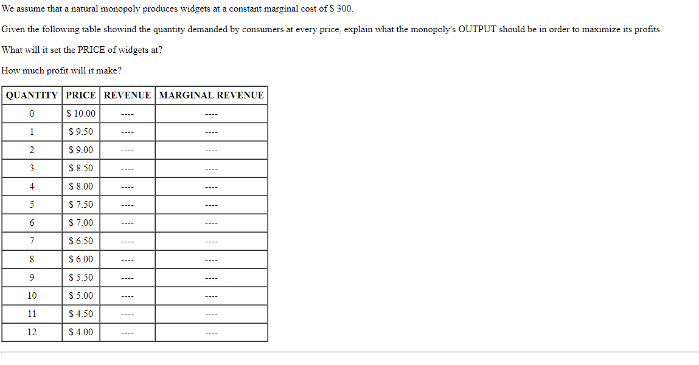
Given the data in problem above, draw the DEMAND and MARGINAL REVENUE curves; show the monopoly output and profit on the graph.

