**Time Series Forecasting and Index Numbers**

**Chapter 15 | Ken Black**

Example: For the past two decades, there has been a heightened awareness of and increased concern over pollution in various forms in the United States. The U.S. Environmental Protection Agency (EPA) regularly monitors levels of air pollution. The two main pollutants in the air are carbon monoxide and nitrogen oxide. Shown below are emission data for two oxides, over a 19-year period reported by the EPA in millions short-tons.





Is it possible to forecast the emissions of carbon monoxide or nitrogen oxides for the year 2011, 2015 or even 2025 using these data?

This chapter is about using different techniques to forecast data. Forecasting is the art or science of predicting the future. It is widely used in decision-making process to help businesses reach conclusions about their activities.

To forecast data, we need Time-series data. Time-series data are data gathered on a given characteristic over a period of time at regular intervals. Time-series forecasting techniques attempt to account for changes over time by examining patterns, cycles, or trends, or using information about previous time periods to predict the outcome for a future time period.

**Time Series Components**

There are four elements of time-series data: trend, cyclicality, seasonality and irregularity. (Note: not all time series data have all these elements).

* Trend: The long-term general direction of data.
* Cycles: patterns of highs and lows through which data move over time periods usually of more than a year. E.g. in the figure below, the data move through two periods or cycles of highs and lows over a 13-year period.
* Seasonal effects: shorter cycles, which usually occur in time periods of less than one year.
* Irregular fluctuations are rapid changes in data, which occur in even shorter time frames than seasonal effects. Irregular fluctuations can happen as often as day to day. They are subject to momentary change and are often unexplained.



Time series data that include no significant trend, cyclical or seasonal effects are said to be stationary. We usually analyze irregular fluctuations with this type of data.

**Measurement of Forecasting Error**

There are several forecasting techniques, but it is difficult to decide which technique is best to use for a given scenario. One way to compare the accuracy of different forecasting techniques is to compare the forecast values with the actual values, and determine the amount of forecasting error. Several methods can be used to compute error in forecasting.

1. Mean Error (ME)
2. Mean Absolute Deviation (MAD)
3. Mean Square Error (MSE)
4. Mean Percentage Error (MPE)
5. Mean Absolute Percentage (MAPE)

**Error**

The error of an individual forecast is the difference between the actual value and the forecast of that value.



**Mean Absolute Deviation (MAD)**

The mean absolute deviation (MAD) is the mean, or average, of the absolute values of the errors.

Example: The table below presents the nonfarm partnership tax returns in the United States over an 11-year period along with the forecast for each year and the error of the forecast. This shows that the errors can be positive or negative.





Mean Square Error (MSE) is computed by squaring each error (thus creating a positive number) and averaging the squared errors.



**Mean Absolute Percentage Error (MAPE)**

To compute MAPE, we must first compute the percentage error for each forecast. Percentage error for each forecast can be computed by dividing the forecast error by the actual value and multiplying by 100. MAPE is the average of the absolute value of percentage forecast errors.

**Smoothing Techniques**

As mentioned earlier, time series data that include no significant trend, cyclical or seasonal effects are said to be stationary. Analysis of such data is conducted using smoothing techniques which produce forecasts based on “smoothing out” irregular fluctuation effects in the data. We are going to study three smoothing techniques in this chapter:

* Naïve and Simple Averaging (Growth and trend adjusted)
* Moving Averages (simple and double moving average)
* Exponential Smoothing

**Naïve Forecasting Models**

These are simple models in which it is assumed that the more recent time periods of data represent the best predictions or forecasts for future outcomes. Naïve models do not take into account data trend, cyclical effects or seasonality. Hence this model is best suited to short-run data, such as those collected on a daily or weekly basis. The simplest of the naïve forecasting methods is the model in which the forecast for a given time period is the value for the previous time period.



Example:



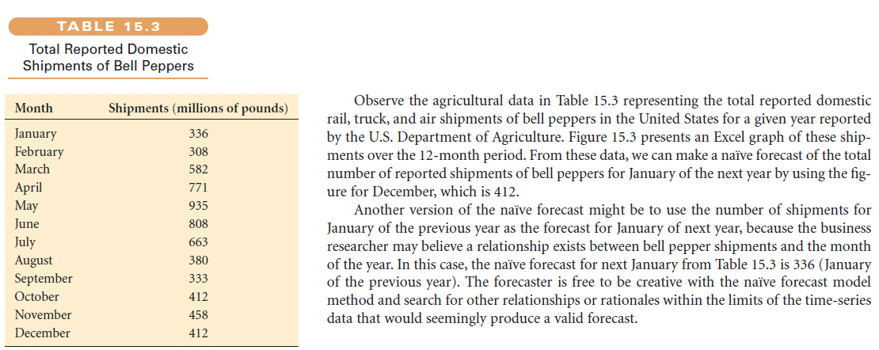

There are two types of adjustments that can be applied to Naïve Forecasting:

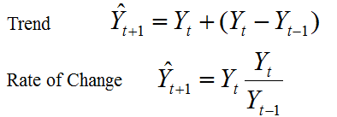

Example:

Use the three methods of Naïve Forecasting to predict the value of sales in the 25th period. Compute the forecasting error.

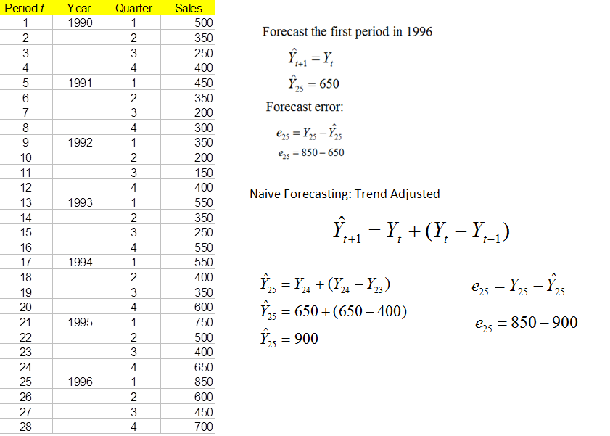

Rate of Change Adjusted

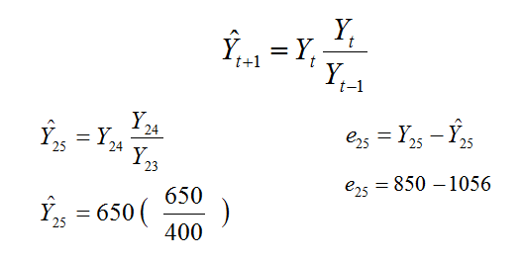

**Averaging Models**

Often forecasts are inaccurate because of irregular fluctuations of the data. Using averaging models a forecaster enters information from several time periods into the forecast and “smooths” the data. Averaging models are computed by averaging data from several time periods and using the average as a forecast for the next time period.

**Simple Averages**

With this model, the forecast for time period t is the average of the values for a given number of previous time periods. Should only be used for stationary data.



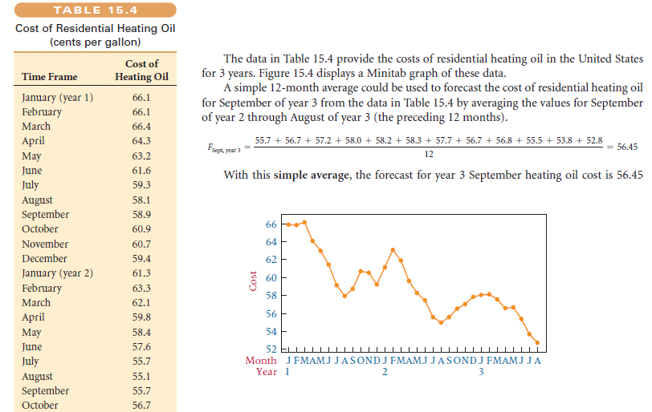

**Moving Averages**

An average that is updated or recomputed for every new time period being considered. This works best with stationary data.



**Other Averaging Models**

* Double Moving Averages - designed to handle trending data. One set of moving averages is calculated and then a second set is calculated as a moving average of the first set.
* Weighted Moving Average - place more weight on recent observations. Sum of the weights needs to equal 1.

**Exponential Smoothing**

This model is used to weight data from previous time periods with exponentially decreasing importance in the forecast. Exponential smoothing is accomplished by multiplying the actual value for the present time period by a value between 0 and 1 (the exponential smoothing constant) referred to as $α$ and adding that result to the product of the present time period’s forecast and $(1-α)$









