Hypothesis Testing for Population Variance ($σ^{2})$
Hypothesis testing for population variance is conducted using chi-squared distribution, provided the underlying population is normally distributed.
Consider the example below:
$$H_{0}: σ^{2}=1 {cm}^{3}$$
$$H_{1}: σ^{2}<1 {cm}^{3}$$
First convert the sample variance to a chi-squared statistic:
df = n – 1
Compare the $χ^{2}$ to the chi-squared critical value that has a $α$ area to the right at df = n – 1.
Interval Estimation
Estimate the value of $σ^{2}$ at 95% confidence.
To compute this, find two chi-squared critical values – one that has an area of $α/2$ on its left and one that has an area of $α/2$ on its right.
Let the chi-squared critical value with $α/2$ on its right be denoted as $χ_{α/2}^{2}$
Let the chi-squared critical value with $α/2$ on its left be denoted as $χ_{{1-α}/2}^{2}$
Lower Confidence Limit (LCL) :
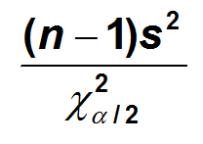
Upper Confidence Limit (UCL):
