**Pearson product-moment correlation**

The Pearson correlation evaluates the **linear** relationship between two continuous variables. A relationship is linear when a change in one variable is associated with a proportional change in the other variable.

For example, you might use a Pearson correlation to evaluate whether increases in temperature at the kitchen of a bakery is associated with decreasing thickness of chocolate coating.

**Spearman rank-order correlation**

The Spearman correlation evaluates the **monotonic** relationship between two continuous variables. In a monotonic relationship, the variables tend to change together, but not necessarily at a linear manner. The Spearman correlation coefficient is based on the ranked values for each variable rather than the raw data.

Spearman correlation is often used to evaluate relationships involving ordinal variables. For example, you might use a Spearman correlation to evaluate whether the order in which employees complete a test exercise is related to the number of months they have been employed.

**The Correlation Coefficients**

|  |  |
| --- | --- |
| **Pearson Product-Moment Correlation Coefficient** | **Spearman Rank-Order Correlation Coefficient** |
| Population Coefficient: $ρ_{p}$*(pronounce: rho-p)* | Population Coefficient: $ρ_{s}$*(pronounce: rho-s)* |
| Sample Coefficient: $r_{p}$ | Sample Coefficient: $r_{s}$ |

Both correlation coefficients have a range from – 1 to + 1. A “crude” way to interpret the values of the coefficients is given in the following table:

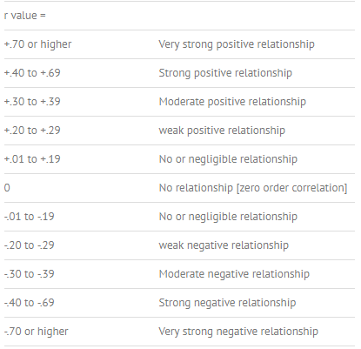

**Spearman Rank-Order Correlation Coefficient**: To calculate the value of *rs*, we rank the data for each variable, *x* and *y*, separately and denote those ranks by *u* and *v*, respectively. Then we take the difference between each pair of ranks and denote it by *d*. Difference between each pair of ranks = *d* = *u* – *v*

Next, we square each difference *d* and add these squared differences to find Σ*d*2. Finally, we calculate the value of rs using the formula:



Use the Spearman Order-Rank Correlation Coefficient table to identify the critical value for conducting hypothesis test about the population correlation coefficient.

Example: Suppose we want to investigate the relationship between the per capita income (in thousands of dollars) and the infant mortality rate (in percent) for different states. The following table gives data on these two variables for a random sample of eight states. Based on these data, can you conclude that there is a monotonic correlation between the per capita incomes and the infant mortality rates for all states? Use α = .05.



Pearson Correlation Sample Coefficient is calculated the following way:

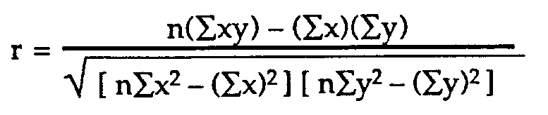

Note: We do not use ordinal ranking for Pearson Correlation Coefficient test.

Example: The table below presents data on the age and blood glucose level of six randomly chosen patients at a diagnostic center. Test if there is a linear relationship between the two variables at 5% level of significance.

|  |  |  |
| --- | --- | --- |
| **Subject** | **Age** | **Glucose Level** |
| 1 | 43 | 99 |
| 2 | 21 | 65 |
| 3 | 25 | 79 |
| 4 | 42 | 75 |
| 5 | 57 | 87 |
| 6 | 59 | 81 |