ECO 101: Introduction to Microeconomics
Monopolistic Competition
Monopolistic competition is a type of market structure characterized by a large number of firms or producers competing to produce a great variety of similar products that they constantly try to differentiate.
Characteristics of Monopolistic Competition Market Structure
- There is a large number of producers of the same type of product in the market;
- Commodities being produced differ from each other only on the basis of product differentiation;*
- There is free entry for new firms and easy exit for existing firms, unlike market characterized by monopoly;
- The demand curve for monopolistic competition is flatter or elastic, which implies that small changes in prices will have a significant impact on the demand of the specific product;
- Advertisement costs are high. Large amounts of money are being spent by producers for the purpose of marketing their products.

*Product differentiation can be in the form of differences in quality, packaging or presentation, service, warranty, marketing or promotion, shape, size, taste, etc. Product differentiation implies that the products are different enough that the producing firms are able to exercise some rights over the prices they charge. This means the demand curve is downward sloping.
In the short-run, firms in monopolistic competition can make an economic profit or loss:
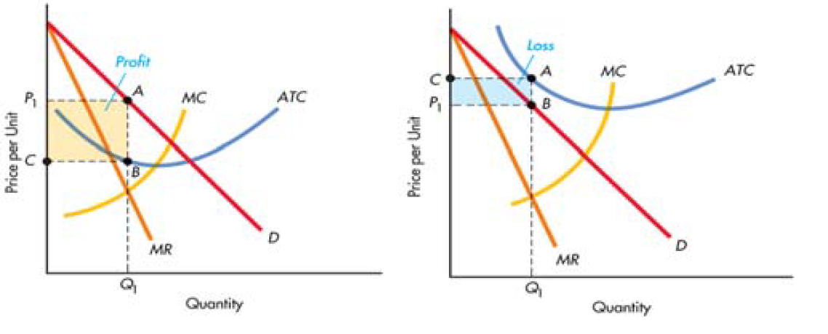
However, in the long-run, firms in monopolistic competition are only able to make normal profits. This is because of free entry and exit of firms in the industry.
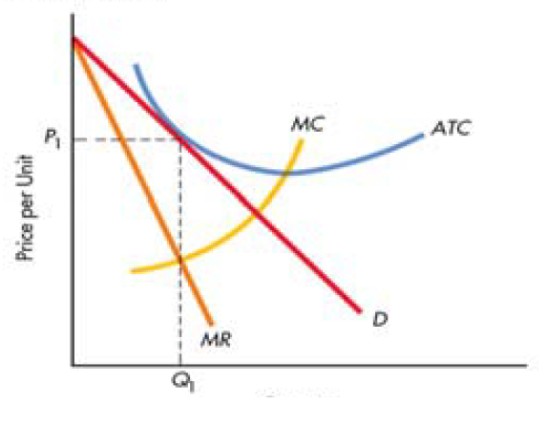
Hence, firms in monopolistic competition make normal profits in the long-run, just like firms in perfect competition. However, monopolistic competition firms charge a higher price and produce lesser quantity than firms in perfect competition in the long-run. Hence firms in monopolistic competition are less efficient than firms in perfect competition.

