Hypothesis Test for Population Mean (µ) (continued…)
In this handout, we will discuss cases for when population standard deviation is unknown to us. In the last handout, cases 1, 2 and 3 were discussed.
Case 4
- Population mean is unknown
- Population standard deviation is unknown
- sample size < 30
- population is normally distributed
Use t-distribution to perform this hypothesis test
Case 5
- Population mean is unknown
- Population standard deviation is unknown
- sample size >= 30
- population may or may not be normally distributed
Use t-distribution to perform this hypothesis test
Case 6
- Population mean is unknown
- Population standard deviation is unknown
- sample size < 30
- population is not normally distributed
Use non-parametric method
Hypothesis Tests for Cases 4 and 5:
If we have to use t-distribution to conduct the hypothesis test, then we first have to convert the sample mean $\left(\overline{X}\right)$ to a t-statistic:
$$t_{\overline{X}}=\frac{\overline{X}-μ}{s/\sqrt{n}}$$
There are two-ways of conducting a hypothesis test:
- Rejection Region Approach
- P-value Approach
Significant level (α) is the probability of rejection.
For cases 4 and 5 we will conduct hypothesis testing only using rejection region approach:

Right-tailed test:
- Since this is a right-tailed test, the rejection region will be to the right of the distribution. Find the t-critical value that has an area of α to its right.
- Compare $t_{\overline{X}}$ to the t-critical value from the table.
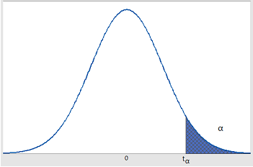
Rejection Rule:
Reject $H_{0}$ if $t_{\overline{X}}≥$ t-critical value
Do not reject $H_{0}$ if $t_{\overline{X}}<$ t-critical value
Left-tailed test
- Since this is a left-tailed test, the rejection region will be to the left of the distribution. Find the t-critical value that has an area of α to its left.
- Compare $t_{\overline{X}}$ to the t-critical value from the table.
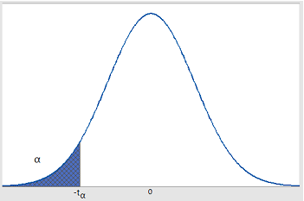
Rejection Rule:
Reject $H_{0}$ if $t_{\overline{X}}≤$ t-critical value
Do not reject $H_{0}$ if $t_{\overline{X}}>$ t-critical value

Two-tailed test
- Find two critical values. One that will have an area of $α/2$ on its right, and one that will have an area of $α/2$ on its left.
- Compare $t_{\overline{X}}$ to the t-critical values from the table.
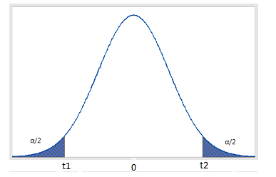
Rejection Rule:
Reject $H_{0}$ if $t_{\overline{X}}≤t_{1}$ or $t_{\overline{X}}≥t_{2}$
Do not reject $H_{0}$ if $t_{1}<t_{\overline{X}}<t_{2}$
Hypothesis Test for Population Proportion ($p$)
So far we have done hypothesis tests about population mean (µ). Now we will do hypothesis tests for population proportion. Proportion means percentage amount as a part of a whole, e.g. the proportion of greenhouse gases in the atmosphere is rising.
Example: Unemployment rate in Bangladesh in 2014 was 4.3%. Suppose we want to test whether the unemployment rate in 2016 was different from 4.3%. Suppose a sample from the 2016 census data of Bangladesh reveal that unemployment rate is 4.5%. Has the population unemployment changed from 4.3% in 2016? This question can be tested using a hypothesis test for population proportion:
$$H_{0}:p=0.043$$
$$H_{1}:p≠0.043$$
$$\text{here}, 1-p=q \text{and }n \text{is sample size}$$
$$\hat{p} \text{is the sample proportion}$$
Hypothesis test for population proportion can be performed using standardized normal distribution if the following requirement is met:
$$np>5$$
$$nq>5$$
If both of these conditions are met, then the sample size is sufficiently large to use standard normal distribution to run the test.
Hypothesis Test for Population Proportion can be done using two methods:
- Rejection Region Approach
- P-value Approach
We will only use the rejection region approach in this class for hypothesis test for population proportion.
First, convert your sample proportion $\hat{p}$ into standardized sample proportion:
$$z_{\hat{p}}=\frac{\hat{p}-p}{\sqrt{\frac{pq}{n}}}$$
The remaining steps of the test are similar to before (refer to handout 1).
Definitions and descriptive questions from Chapter 9:
Q1. What are null and alternative hypotheses?
Q2. Define Type I and Type II errors. Give an example of a scenario to illustrate type I and type II errors.
Q3. What are the two procedures for doing hypothesis testing?
Q4. Differentiate between Cases 1, 2 and 3.
Q5. Differentiate between Cases 4, 5 and 6.
Q6. What are the requirements for using normal distribution to conduct hypothesis testing for population proportion?

