Hypothesis Testing for Population Mean $\left(μ\right)$
Case 1:
- Population mean is unknown
- Population standard deviation is known
- Sample size < 30
- Population is normally distributed
In this case, we can use normal distribution to run the hypothesis test
Case 2:
- Population mean is unknown
- Population standard deviation is known
- Sample size >= 30
- Population may or may not be normally distributed
In this case, we can use normal distribution to run the hypothesis test
Case 3:
- Population mean is unknown
- Population standard deviation is known
- Sample size < 30
- Population is not normally distributed
In this case, use non-parametric method.
Case 4:
- Population mean is unknown
- Population standard deviation is unknown
- Sample size < 30
- Population is normally distributed
In this case, use t-distribution to perform hypothesis test.
Case 5:
- Population mean is unknown
- Population standard deviation is unknown
- Sample size if >= 30
- Population may or may not be normally distributed
In this case, use t-distribution to perform hypothesis test
Case 6:
- Population mean is unknown
- Population standard deviation is unknown
- Sample size if < 30
- Population is not normally distributed
In this case, use non-parametric method.
In Chapter 9, we only work with cases 1, 2, 4, 5.

Methods to run hypothesis test
There are two ways to run a hypothesis test.
- Rejection region approach
- P-value approach
For Cases 1 and 2, we use normal distribution to run the hypothesis test.
Suppose sample mean $=\overline{X}$. We first have to standardize this value:
$$Z_{\overline{X}}=\frac{\overline{X}-μ}{σ/{\sqrt{n}}}$$
Significance level: $α$(usually very small, like 0.1, 0.05, 0.025..)
Left-tailed test
- Rejection Region Approach

- Find the z-critical value that has an area of $α$ to the left.
- Compare $Z_{\overline{X}}$ to the z-critical value
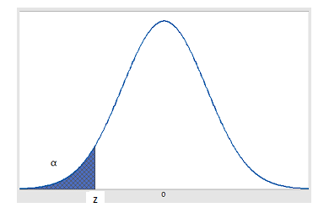

Rejection Rule for left tailed test:
Reject $H_{0}$ if $Z_{\overline{X}}≤$ z critical value
Do not reject $H_{0}$ if $Z_{\overline{X}}>$ z critical value

- P-value Approach
For left tailed test, find the area to the left of $Z_{\overline{X}}$
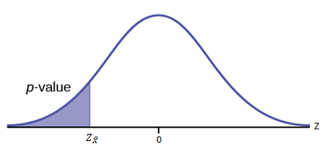
Reject $H_{0}$ if p-value < $α$
Do not reject $H_{0}$ if p-value > $α$

Right-tailed test
- Rejection Region Approach

- Find the z-critical value that has an area of $α$ to the right
- Compare $Z_{\overline{X}}$ to the z-critical value
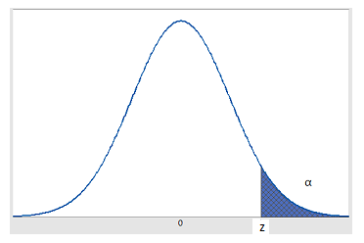
Rejection Rule for right tailed test:
Reject $H_{0}$ if $Z_{\overline{X}} ≥$ z critical value
Do not reject $H_{0}$ if $Z_{\overline{X}}<$ z critical value

- P-value Approach
For a right-tailed test, p-value is the area to the right of $Z_{\overline{X}}$.
Reject $H_{0}$ if p-value < $α$
Do not reject $H_{0}$ if p-value > $α$

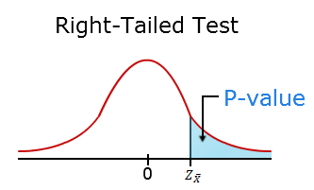
Two-tailed test
- Rejection Region Approach

- Find two z-critical values. One that has an area of $α/2$ to the right, and one that has an area of $α/2$ to the left.
- Compare $Z_{\overline{X}}$ to the z-critical values
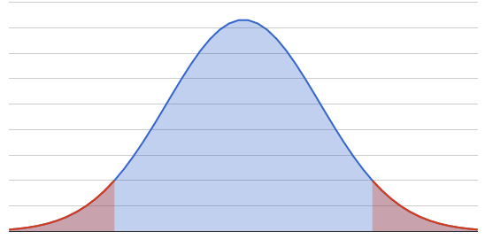
Rejection Rule:
Reject $H_{0}$ if $Z_{\overline{X}}≤z_{1}$ or if $Z_{\overline{X}}≥z_{2}$
Do not reject $H_{0}$ if $z_{1}{<Z}_{\overline{X}}<z_{2}$
- P-value Approach
For two-tailed tests, p-value is calculated as follows:
If $Z_{\overline{X}}<0$ , then p-value is $2×P\left(Z<Z_{\overline{X}}\right)$
If $Z_{\overline{X}}>0$ , then p-value is $2×P\left(Z>Z_{\overline{X}}\right)$
Reject $H_{0}$ if p-value < $α$
Do not reject $H_{0}$ if p-value > $α$
Handout for hypothesis tests for Cases 4 and 5 will be distributed next class.

