$$E_{d}= \frac{Percentage Change in Quantity Demanded}{Percentage change in Price}= \frac{\%ΔQ_{d}}{\%ΔP}$$
$$E_{d}=\frac{\frac{ΔQ_{d}}{Q_{d Average}}}{\frac{ΔP}{P_{average}}}$$
$$E_{C}= \frac{Percentage Change in Quantity Demanded of one good}{Percentage change in Price of another good}$$
$$E_{Y}= \frac{Percentage Change in Quantity Demanded}{Percentage change in Income}$$
$$E_{Y}=\frac{\frac{ΔQ_{d}}{Q_{d Average}}}{\frac{ΔY}{Y_{average}}}$$
$$E_{S}= \frac{Percentage Change in Quantity Supplied}{Percentage change in Price}$$
$$MU= \frac{∆ TU}{∆ Q}$$
Utility Maximization Condition:
$$\frac{{MU}_{1}}{P_{1}} =\frac{{MU}_{2}}{P_{2}}$$

- Profit = Total Revenues – Total Cost
- Total Revenue = Price per unit * No. of units sold

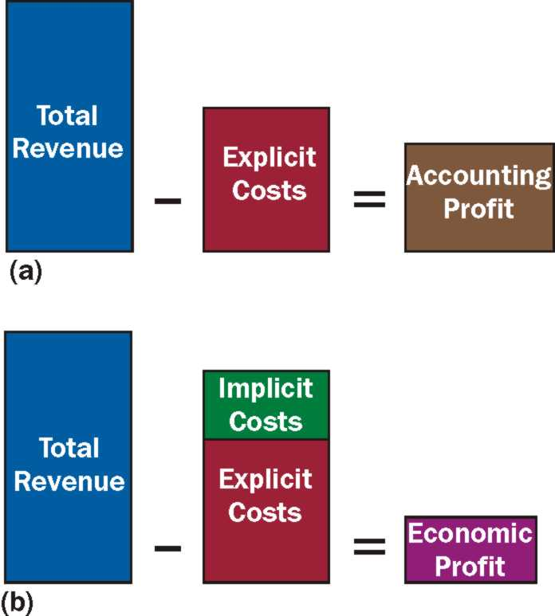

- Total costs: Sum of fixed and variable costs
$$MPP=\frac{∆Output}{∆Variable Input}$$
- MC = ∆TC/∆Q
- AFC = TFC/Q
- AVC = TVC/Q
- ATC = TC/Q or ATC = AFC + AVC

